# This article is about the OT-One.

## **It's no-longer sold or actively supported by Opentrons, but we've kept this article here to help existing users. Please** [**see our OT-2 Support articles**](https://support.opentrons.com/) **for the most up to date information!**

## **Overview:**

For our first protocol, we will be drawing a dinosaur (a stegosaurus to be specific) on a 96-well plate!

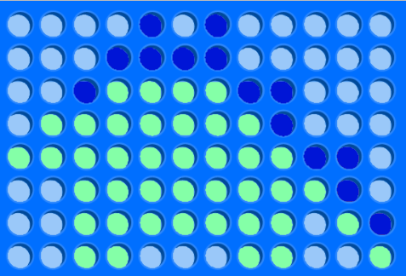

We will be using two colors, so be sure to find some food dye, or colored liquids you can use. In this tutorial, we’ve chosen to use blue and green food dye in water.

## **Materials:**

1. 96-well plate
2. 12-row trough
3. Opentrons tip rack with adapter
4. 200uL tips
5. 200uL Dragon Lab pipette

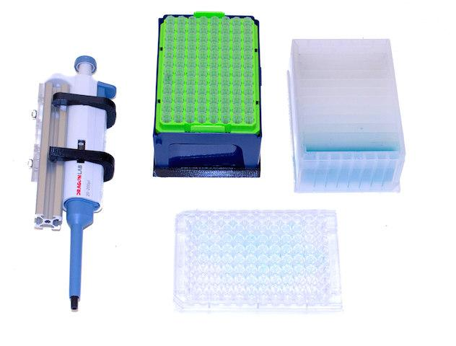

## **Procedure:**

# Upload and Calibrate

## **Step 1:**

First, visit our protocol library and download the [dinosaur protocol](https://protocols.opentrons.com/protocol/dinosaur).

Note: This protocol is for the P300 single channel pipette

If you are using a P1000 single channel please download [dinosaur_p1000](https://drive.google.com/open?id=1HsVodNRMBdgffwHmjZ_aTuVY6kDEvzMB)

If you are using a P10 single channel please download [dinosaur_p10](https://drive.google.com/open?id=1KOv0HsiWQGta7sln-r2lNE2MYY2UZR62)

Then, upload it into the OT App.

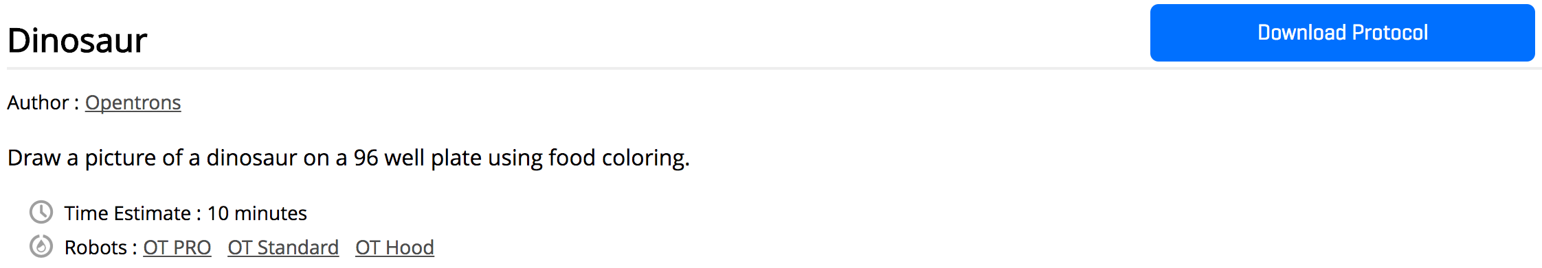

## **Step 2:**

Place all containers in their designated slot on the robot.

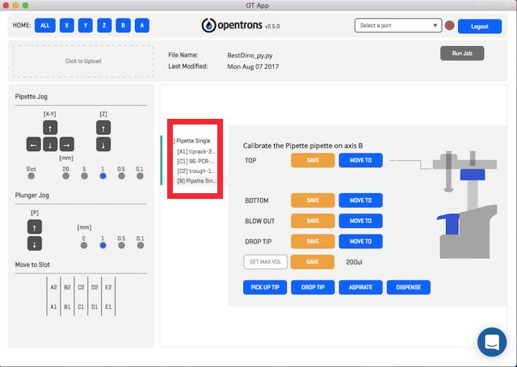

In the protocol above:

A1 - 200 uL tiprack

C1 - 96 well plate

C2 - 12 channel trough

B axis - 200 uL single channel pipette

## **Step 3:**

See the image below for the slot names and locations of the containers we will be using for the Dinosaur Protocol.

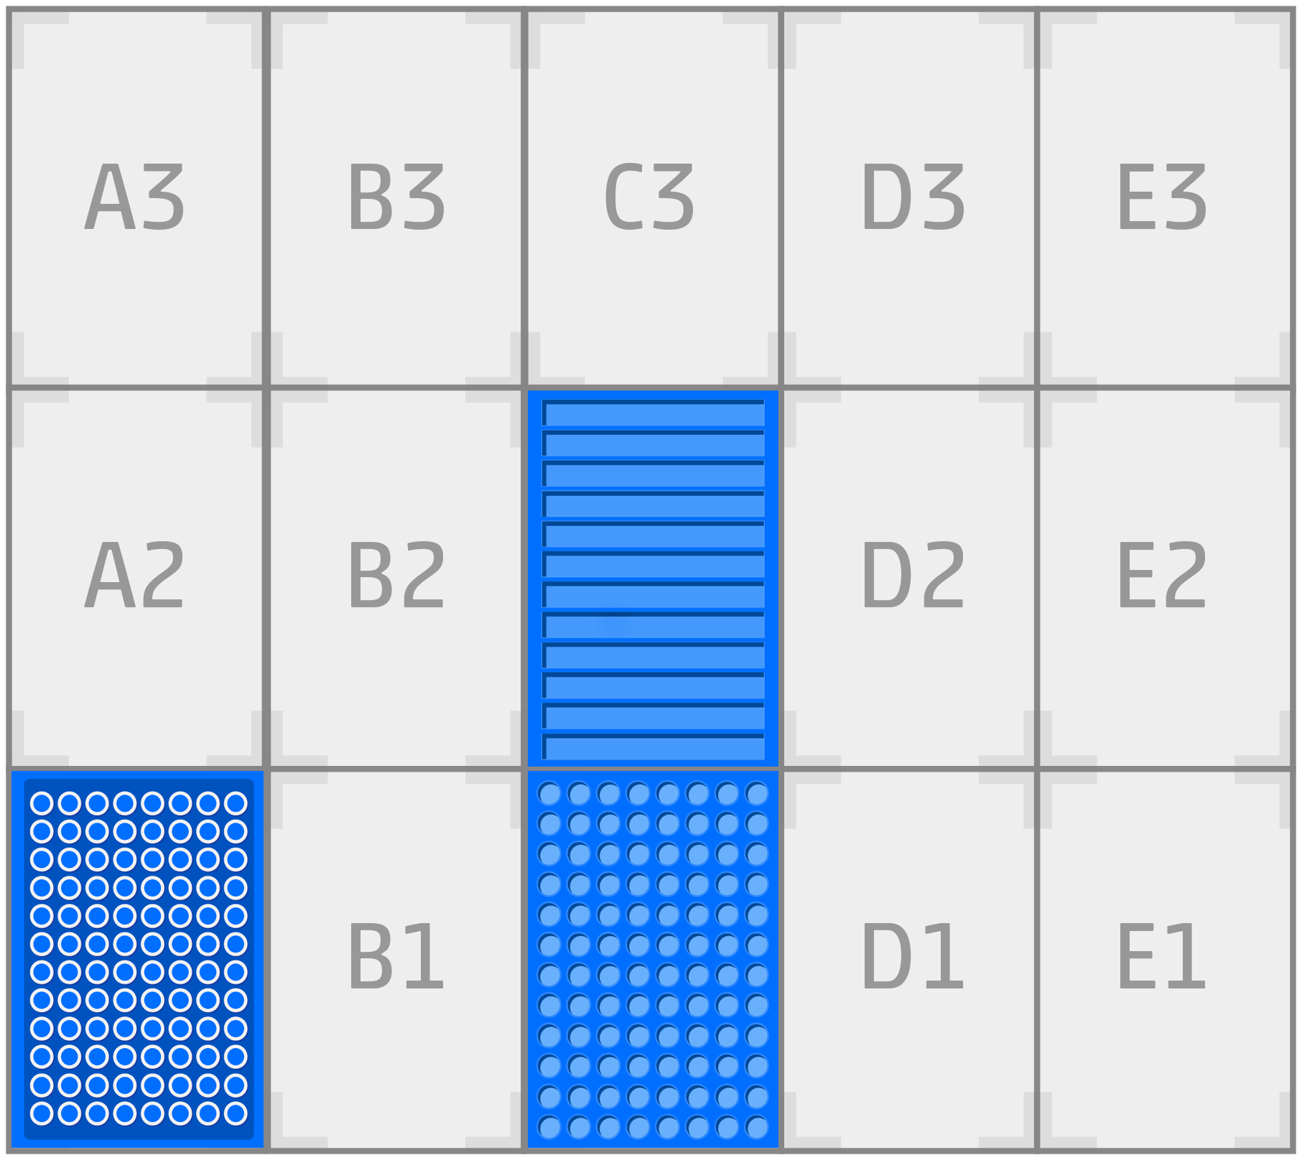

Step 4:

Set up the trough - Add your colored liquids to the trough. The Dinosaur Protocol uses the trough's first two wells, well “A1” and well “A2”, for it’s two color sources.



## **Step 5:**

You will need to calibrate the tip rack, 96-well plate, 12-row trough, as well as the pipette. Make sure to save position of each calibration on the app. It is also good practice to home between each calibration run.

* Tip Rack - Calibrate the pipette to the center of the A1 tip in your container.



* 12 row trough - Calibrate the pipette to the bottom of the A1 slot of your container.



* 96 well plate - Calibrate the pipette to the bottom of the A1 well of your container



For additional assistance on calibration, please refer to the articles on the support page for [container calibration](https://support.opentrons.com/getting-started/software-setup/calibrating-the-deck) and [pipette calibration](https://support.opentrons.com/getting-started/software-setup/calibrating-the-pipettes).

*** If you do not see all the checkmarks in your container calibration please refer to this [article](https://support.opentrons.com/ot-one-app/check-marks-do-not-appear-when-saving-calibration-positions).

# Run Protocol

Okay, once all positions are saved on the OT App and there are green check marks next to each container and pipette, you’re ready to run!

Make sure there is no tip on your pipette, and that the tip rack is full with a tip in position “A1”.

Step 6:

To begin running a protocol, double-check to make sure every container has been properly calibrated and press the “Run Job” button at the top right corner of the app.

Once running, a list of commands will be printed out into the app as they occur, and a progress bar will appear. If anything goes wrong and you wish to either momentarily pause/resume or completely cancel the protocol, those buttons are available to you in the top right corner.

Otherwise, if you've successfully calibrated all of your containers and can run your protocol, watch as a dinosaur is printed onto your plate!

